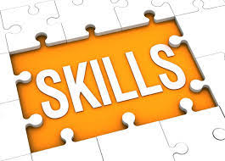
IMPROVING YOUR LANGUAGE SKILLS
PERSONAL TOP OF THE FLOPS NAME:
-
If you really want to benefit from your class tests, analyse your mistakes and update your personal top of the flops
SPELLING MISTAKES (Words that I often spell wrong)

VOCABULARY & PREPOSITIONS (Important words or prepositions that I got wrong)

GRAMMAR (My top five of typical grammar mistakes, e.g. wrong tenses, word order …)
(1)
(2)
(3)
(4)
(5)
STYLE (How I can improve my style)

-

